Travel & Expenses

Policy and Procedure
Policy Statement
This policy sets out Lancashire County Council's rules on business travel and aims to ensure that employees are properly reimbursed for legitimate business expenses that are incurred by them in the performance of their duties. In addition, we want to ensure that we provide reasonable standards of facilities, comfort, convenience, and safety for those who need to travel on council business.
Scope
This policy applies to all council employees on LCC terms and conditions, excluding teaching and non-teaching staff employed by schools and employees who transferred to the council in accordance with TUPE regulations and who remain on their previous terms and conditions of employment. For clarity, all employees are eligible to claim expenses, however for employees who have TUPE transferred, you may be eligible to receive the rates applicable to your previous terms and conditions of employment.
The Travel & Expenses Policy supersedes the former policies and procedures relating to business travel, car categorisation, driving licences and motor insurance of privately owned vehicles, travel outside of Great Britain, expenses over three months old, overnight allowance, payment for travel outside normal working hours, requirements to qualify for meal allowances and telephone allowances – these documents are now incorporated into the scope of this policy.
Definitions
The following definitions apply for the purpose of this policy:

Business travel expenses include:
- public transport costs (including air travel, travel by ferry or taxi, in limited and exceptional circumstances);
- reimbursement of business mileage for cars, motorcycles, and bicycles; and
- reimbursement of car parking fees (where incurred).

Business travel expenses do not include:
- The costs of any normal commuting. Normal commuting costs will not be reimbursed.
- The cost of any travel undertaken for non-business reasons. These expenses will not be reimbursed.
- Any fines or penalties incurred whilst on council business for whatever reason, including penalties for not paying for a rail ticket in advance of boarding a train and penalties or fines associated with motor offences, including speeding and parking fines, clamping or vehicle recovery charges. Fines or penalties incurred whilst on council business will not be reimbursed.
- Travel costs associated with the undertaking of any work related, or qualification, training is claimable in line with the business mileage criteria below, however you should refer to the training mileage rates in the allowances and expenses table as the rate you can claim differs to the business mileage rate.
- Excess travel costs incurred as a result of the relocation of the workplace of employees. The arrangements concerning excess travel are set out under the council's Compensation Payments Policy.
- Relocation costs, as set out under the council's Relocation Allowance Scheme, incurred as a result of employees relocating their place of residence as a direct result of taking up their appointment with the council.

Principles
We are committed to having a responsible travel and expenses policy which is fair and reasonable for all staff.
Business travel has a substantial impact on both costs to the council and the environment, so it is important as a collective that we always consider whether travel is absolutely essential to undertake our duties. In considering whether there is an essential requirement to travel, you should look at whether the work, meeting or visit could be carried out remotely in order to avoid any unnecessary travel.
This policy should be used to determine what you can and cannot claim. If you can make arrangements to avoid expenditure, we would encourage you to do so.
The overriding philosophy of this policy is that you can claim for a contribution where you have been prevented from following your normal travel/meal/accommodation arrangements as a result of an operational need, and therefore have incurred additional expense as a result.
It is ultimately your responsibility to ensure that all expenses that you submit are done so in accordance with this policy.
Business Travel & Allowances
Is My Travel Necessary?
We can all help to reduce costs and our impact on the environment by questioning if your journey is needed.
Before arranging travel consider:
- Could you use MS Teams or other teleconferencing systems instead?
- Have you limited those travelling to only who is necessary?
- Could you organise your travel in such a way that you reduce the need to return at a later date or cover more appointments in that geographical area?
- Could you consider an alternative location which reduces travel for participants?
- Will there be a negative impact on the customer/service user if you do not see them face to face?

Seek clarity and approval from your manager where appropriate.

Alternative Options to Commuting
Consider if you could walk or cycle, this is excellent for the environment, and with limited parking facilities at some of our workplaces, it will allow us to prioritise business needs and those with specific requirements. Walking and cycling is also really beneficial for your health and wellbeing. The council has access to a Cycle to Work Scheme. Further to this you could consider the use of public transport – a number of our workplaces have excellent public transport links for rail or bus. This also reduces our carbon footprint and allows us to do our bit for the community by reducing congestion and environmental impact.

Business Mileage
Business mileage is the number of miles travelled in connection with an essential business journey.

If you use your own vehicle to undertake a business journey in connection with the performance of your work duties as set out below, you will have the business mileage you have incurred reimbursed in accordance with the HMRC approved mileage rates set out within the council's Allowances and Expenses Table for the type of vehicle you have used.

Business mileage can be claimed for travel that incurs an additional cost to you when undertaking your duties in accordance with HMRC criteria. Any travel which is considered a commute to your permanent workplace, or any personal travel that is not connected with work, is not claimable. In the event you live outside of the county boundary, you can only claim mileage from the point you enter the Lancashire boundary. For clarity, the boroughs of Blackburn with Darwen and Blackpool will be regarded as within the county boundary. Google maps can be used to view the county boundary and should be used in conjunction with a reputable route finder such as AA or RAC to establish what you can or cannot claim. In the event you are required to travel outside of the county boundary for operational/business purposes, you are able to claim for the full journey. You are expected to take the most direct route and plan your journeys ahead wherever possible to limit the distance of travel.

In the event you claim for mileage which is considered a commute or personal travel by HMRC this could result in you personally being liable for any tax that should have been paid – so it is really important you make an assessment as to what is and isn't claimable using the information below.

What journeys can I claim mileage allowance for?

In principle you can claim the additional cost of travel incurred on all journeys carried out for the purposes of your role, but you cannot claim your commute from your home to and from your permanent designated workplace. Full mileage can be claimed from your permanent workplace to temporary workplaces (and the return journey). In some circumstances, you may have to deduct your normal commute to and from your permanent workplace – in accordance with the criteria, as set out below:
- In the event you need to visit a temporary workplace on the way to your permanent workplace, you can claim your actual mileage for the journey, less your normal commuting mileage.
- If you travel from home to a temporary workplace (in excess of your usual commute, i.e. past the workplace) and your journey takes you within a five-mile radius of your permanent workplace, you can claim your actual mileage for the journey, less your normal commuting mileage.
NOTE - If you live outside of the county boundary, your claim can only begin once you reach the Lancashire boundary, unless you are required to travel outside of the boundary for business purposes.
Mileage Claims Criteria – How do I know what I can claim?
To work out whether you have to deduct your commute – answer the following questions:
- Q1. Does your first journey take you to a temporary workplace within a five-mile radius of your permanent workplace AND is it in excess of your usual commute? If yes, deduct your usual commute from your claim.
- Q2. Is your journey from home to a temporary workplace but it does not come within a five-mile radius of your permanent workplace? If yes, you can claim for your full travel.
- Q3. Are you stopping off at a temporary workplace on the way to your permanent workplace (i.e. your travel is largely along your usual commute and you are 'stopping off' at a temporary workplace)? If yes, deduct your usual commute from your claim.
- Q4. Is your journey from your home to your permanent workplace? If yes, this is classed as a commute and is not claimable.
- Q5. Is your journey from home to a temporary workplace and is not in excess of your usual commute? If yes, regardless of if you come within a five-mile radius of your permanent workplace, you can claim for your full travel.

You can only claim mileage for your actual travel in line with the above. You are expected to take a sensible approach in claiming for mileage, taking the most direct route possible, where mileage is accrued for business purposes only and where an additional cost is incurred.

Examples of how to claim mileage are attached to this policy.

You can claim for travel costs associated with the undertaking of any work related, or qualification, training. Please refer to the training mileage rates in the allowances and expenses table as the rate differs to the business mileage rate.

What is a commute?

In simple terms, a commute is any travel between a permanent workplace and your home (or other locations in the event you travel from elsewhere – for example if you stayed with a relative or friend and travelled to work from that location). This is not claimable.

What is personal travel?

Personal travel is a journey between your home and any other place you do not have to be for work purposes, or any two places you do not have to be for work purposes. This is not claimable.

What is a permanent workplace?

Normally you will be able to easily identify your permanent workplace as this is somewhere that you travel to on a regular basis to undertake your role, or it may be outlined in your contract of employment. Your manager will be able to confirm your permanent workplace.

In the event you apply and are successful for a secondment in a different location for a fixed period of time, the new location will be considered your permanent workplace.

In the event you are relocated due to a restructure you may be eligible to claim excess mileage in line with the Compensation Payments Policy.

The work undertaken at this location would be directly related to your role and long term/ongoing duties, as opposed to a time limited one-off task (for example a meeting, to perform repairs or to conduct a survey). You may have more than one permanent workplace. In the event you travel between two permanent workplaces, you can claim for travel between the two, but any travel from home to the permanent workplace would be considered a commute.

Your permanent workplace would include locations where you are routinely allocated tasks (such as a depot) even if tasks are performed elsewhere.

It is important to note that you will still be considered to have a permanent workplace if the organisation has provided facilities for you to work in to carry out your role and you choose to work from home (or are required to work from home due to pandemic restrictions for example).

What is a temporary workplace?

A temporary workplace is somewhere you would go only to perform a task of limited and short duration, for a particular reason/task or for a temporary purpose. For example, it may be a meeting with colleagues, or with service users, or to conduct repairs, but it would be self-contained to that purpose.

More information on HMRC rules around business mileage can be found here. Examples of what is and isn't claimable is available at appendix one of this policy.

Mileage costs will be reimbursed at the rates set out within the Allowances and Expenses Table.

Overtime Working & Callout
In the event you work overtime or are called out due to an emergency, the normal business mileage rules apply, and you cannot claim for any commute to your permanent workplace or any personal travel.
Please see Payable Enhancements for further information about call out overtime rates/time off in lieu arrangements.
Driving at Work E-learning
The Driving at Work e-learning course is a mandatory course that all employees who drive to and from work, or drive as part of their work duties, are required to undertake. Your manager will not be able to authorise claims for business mileage until the course has been successfully completed.

Journeys by Public Transport
All public transport journeys must be made by the cheapest fare/ticket option that is available taking account of travel requirements.

It is expected that where there is the facility for travel tickets to be booked in advance that requisitions are made as soon as travel arrangements are confirmed via the Oracle Financials system. There will be people in your service area who are able to place orders and book travel on Oracle on your behalf. Oracle Requisitioners can book travel for LCC staff via the link on the iProcurement home page, selecting 'Travel and Accommodation'. If you're unsure who your Oracle requisitioner is, please speak to your line manager. This is to ensure that the most cost-effective travel option can be used, and the costs are charged to a service budget code avoiding the need for you to incur costs.

Second or standard class travel options should generally be used but first or business class travel may be used in cases where the ticket cost is less than that of a standard class ticket (e.g. in the case of any promotions that rail operators are running where tickets are booked in advance). Open tickets should be avoided as they are often more expensive, however flexible tickets can be used for journeys where travel plans are not confirmed, or an off-peak ticket is not feasible. In exceptional circumstances travel by first or business class can be approved by the relevant Director or Head of Service. Please take advantage of any offers which reduce the cost of travel.
Taxis are generally a costly method of travel and should only be booked in exceptional circumstances – for example due to disability requirements, or where personal safety is a concern (early morning/late evening travel). Taxis should be pre-booked wherever possible and only used for short journeys (for example to travel from home to a railway station to catch a train).
Generally speaking, you should look for the most cost-effective option wherever possible, balancing the convenience and time/duration of the journey.

Travel outside of Great Britain
The following arrangements apply in the event you are required to travel outside of Great Britain in connection with your official duties. You should seek approval from your line manager before making any travel arrangements of this nature.

For these purposes travel to Northern Ireland, the Isle of Man and the Channel Islands qualifies for payment of the allowance as they are considered outside of the United Kingdom of Great Britain. This provision does not apply to other offshore islands e.g. Isle of Wight, Anglesey, Hebrides, etc., which are part of the UK National and Local Government system.
The following expenses can be claimed:
- Accommodation - bed and breakfast only. There is no upper limit, but this is on the basis that the standard of accommodation is that normally arranged by Business Travel Organisations and is booked through the Oracle Financials system;
- Travel to and from this country to the destination by the most economical means;
- Hospitality for visitors and guests (receipts to be produced wherever practical) if pre-approved by management.
For all other expenses, including travel whilst abroad (e.g. taxis, public transport, use of own car, etc.) and subsistence expenses, a flat rate per day should be claimed (see Allowances and Expenses Table) and invoices/receipts need not be produced. It is expected that you would not claim expenses if you were in receipt of hospitality which did not incur a cost. This allowance will be reviewed annually in line with RPI rates.
Car Parking
You are able to claim car parking fees that are incurred as a result of travelling on council business, except where the fees are incurred as a result of you attending your permanent workplace, or any other location that you are using as a substitute work base on any given day.

Overnight Allowance
These allowances are linked to the Members' Allowance Scheme agreed by the council and will be updated annually in line with that scheme.

Wherever possible overnight accommodation will be booked and paid for by the council. There will be people in your service area who are able to place orders and book travel on Oracle on your behalf. If you're unsure who your Oracle requisitioner is, please speak to your line manager. Normal subsistence allowance arrangements will apply in relation to any meals not provided. In exceptional circumstances where it is not possible for the council to make a direct booking the actual receipted cost of accommodation, including breakfast, will be reimbursed subject to the following maximum limits set out in the Allowance and Expenses Table.
There are no separate allowances for attendance at authorised conferences. No entitlement exists where accommodation and all meals are provided at no cost to you.
Subsistence Allowances
It is generally expected that you will make arrangements for meals when undertaking the course of your duties. Meal allowances will be available however to you in the event you are prevented by your official duties from arranging/taking a meal at your home or permanent workplace, where you normally take your meals. You should retain and provide receipts for any expenses incurred. These allowances will only be payable when you travel outside the boundaries of Lancashire. (For this purpose, the boroughs of Blackburn with Darwen and Blackpool will be regarded as being within the Lancashire boundary).

Meal | Allowance Requirements
Breakfast | You must have left your home or permanent workplace you normally take your meals at least two hours before you would normally start work.
Lunch | You must be away from your home or permanent workplace where you normally take your meals during the normal lunch period, which for the purpose of qualifying for a meal allowance is 12 noon to 2.00pm.
Dinner | Claims for dinner can be made where you are required to work after 8:30pm, or if you are required to have an overnight stay outside of the boundaries of Lancashire due to your official duties. You are permitted to take a dinner break at times that are operationally convenient.

Note: The payment of these allowances is, of course, dependant on additional expenditure having been incurred.

Telephone Call Claims

In exceptional circumstances where you do not have access to a company mobile phone, office phone or MS Teams number and you are required to make business calls that incur a cost to you personally, you can claim for the cost of the call as an incidental expense. You must provide evidence of the business calls made and the resulting charges from your phone provider. You should discuss any difficulties with your manager in order to resolve any technical issues or to arrange access to the required telephony equipment as soon as possible under these circumstances.

How to Claim Expenses
You must ensure that regular monthly claims are submitted for expenses via the Oracle HR & Payroll System. All claims must be submitted within a three-month period of the expense being incurred. Any claims that fall outside of this period will only be authorised for payment where you have been prevented from submitting the claim sooner. Full details of the journey, including the date, reason for journey, and route details should be shown on your claim. Business miles to be claimed must be entered and the amount claimed should be shown as appropriate. You are encouraged to keep evidence of your travel in case of any audit requirements. This can be done by logging appointments on your Outlook calendar or by keeping a separate document. Claims for all expenses must be supported by receipts (where appropriate).
Please refer to the allowances and expenses guide for more advice on how to make an expense claim.
Car Categorisation
If you are in a post that is designated by the council as an "essential car user", you are required to provide a motor vehicle that is insured by you for business purposes in connection with your duties.
Although the expectation is that post holders in essential car user posts have a motor vehicle readily available on a daily basis, if there are no planned journeys on a particular day and the duties are such that they will not be required to make a journey at short notice they may leave their vehicle at home.

All other posts are designated as "occasional car users" and these post holders are not required to provide a motor vehicle for use by them for business purposes.

Driving Licences and Motor Insurance of Privately Owned Vehicles
If you drive in the course of your work, it is your responsibility to ensure that you hold a valid driving licence, a roadworthy vehicle, MOT and motor insurance that covers you for business use in order to use a motor vehicle, whether owned by yourself or not, on council business. A valid MOT certificate must be available for all vehicles over 3 years old and this should be available for inspection on request. Drivers must always ensure that their car is in a good state of repair and is roadworthy before undertaking any journey to reduce the likelihood of accidents or breakdowns.

Motor Insurance Requirements
The use of motor vehicles is subject to compulsory third party insurance cover under the Road Traffic Acts and, if you use a private motor vehicle (whether owned by you or not) on council business, it is your responsibility to ensure that you have a current insurance policy in place providing cover against third party liability during such use. Whenever you drive a privately owned vehicle on council business, you are required to ensure that such use is covered by a Motor Insurance policy which would meet your legal liability towards third parties.

In no circumstances must you carry passengers on a motorcycle whilst on council business.

Should you require any further information on Motor Insurance Requirements, please visit this link for more information.

Checking of Driving Licences and Motor Insurance
The procedure below details the arrangements for checking driving licences and the insurance of private motor vehicles used for business purposes.

NOTE: The paper counterpart to the photo card driving licence is no longer valid and is no longer issued by DVLA. Paper driving licences issued before the photo card was introduced in 1998 will remain valid. This means that since 8 June 2015 neither the photo card driving licence, nor the paper licence provides an accurate account of any driving endorsements. Instead, this information is held on DVLA’s driver record, and can be accessed by post, by phone or online on the GOV.UK website. Managers should use the Check Driving Licence service to check the licence for any endorsements or penalty points using a 'check code' provided by the driver.
- If you are a photo card driving licence holder you are required to renew the photo card licence before it expires, and licences must be checked by your manager annually and when they have been renewed.
- Your driving licence must be checked by your manager on appointment, if you are employed as a driver of council vehicles or employed in a post that is designated as an "essential car user" post using the GOV.uk website. The licence will be checked to ensure that it is valid, the name and address on the licence is correct, that you are not currently disqualified from driving and are able to drive the appropriate category of vehicle. Mileage expense claims cannot be submitted until this check has been completed.
- Appropriate records will be kept to enable the council to demonstrate to our motor insurers that we are taking reasonable measures to comply with the policy requirements.
- If you are an essential car user, you must present your vehicle insurance certificate on appointment, which must clearly indicate that the vehicle is insured for business purposes in accordance with the principles above, to your manager. Your manager must validate the insurance details on Oracle Expenses. Mileage expense claims cannot be submitted until this process has been completed.
- Insurance details need to be re-authorised annually in accordance with insurance renewal dates and it is your responsibility to provide evidence of this to your manager. Oracle Expenses will not accept further claims for mileage expenses without this information.
- If you are an occasional car user, you must also have business insurance cover for the vehicle you use before you undertake any mileage. This includes training mileage. Your driving licence and vehicle insurance certificate will also be checked before you undertake any mileage and before you can submit any mileage claims.
- If you are employed as a driver or designated as an essential car user, it is your responsibility to inform your manager of any criminal offences, investigation, cautions and/or convictions that have taken place during or outside of work, including any motoring offences whilst undertaking council duties, which may impact on your employment. In the event you are either prevented or disqualified from driving, you must notify your manager of this immediately. Failure to do so may result in action being taken under the council's Disciplinary Procedure. It is important that if you need to drive you are fit and well to do so and you must keep your manager informed of any medical conditions that may impact on your ability to drive. If you have a medical condition and are unsure whether this may affect you whilst driving a vehicle, you should seek advice from your GP. More information is also available on the Gov.uk site linked here,
Council Fleet
Please note, if you are only required to drive vehicles owned by the council (and part of the council fleet), you will not be required to provide insurance or MOT documentation. You may also be subject to more regular licence checks and required to complete a medical declaration in line with departmental standards.
Documents & Useful Links
- Relocation Allowance
- Compensation Payments Policy.
- Allowances and expenses guide
- Allowance and Expenses Table
- Cycle to Work Scheme

Appendices:
- Appendix 1 – Business Mileage Scenarios & Examples

Policy Version Control
Version | Date | Change
2 | ##/##/23 | - Added five-mile radius to determine whether a journey is constituted as passing the workplace  - Removed reference to HMRC criteria to define a permanent workplace for simplification purposes.  - Additional examples added to guidance.
1 | 21/06/20 | - Removed section relating to telephone installation, rental charges as there is no evidence that this is being claimed.  - Mileage claim criteria updated in line with HMRC guidance. Removed five-mile radius from mileage claim criteria. Added ability to claim outside of the county boundary if it is required for business purposes.  - Included ability to claim for dinner allowance if an overnight stay  - Ability to claim for mileage for callout to designated base now removed to ensure compliance with HMRC tax relief.  - The requirement to provide a V5 certificate for personal vehicles used for business purposes has been removed.  - Driving licences now need to be checked annually by managers in conjunction with motor insurance.

Appendix 1 – Business Mileage Scenarios & Examples
Some examples of what is and is not claimable are as below:
Scenario 1 - Catering Manager – Travelling to temporary workplaces, to their permanent workplace, and then to their home.

A catering manager is required to travel to multiple school establishments to undertake their role, on each occasion visiting each establishment for a temporary purpose (for example, 1:1's or management meetings). Their designated workplace is County Hall in Preston and they live in Euxton.

In this case, the catering manager is required to travel from home to a school in Chorley, then to a school in Tarleton, and onto County Hall for a meeting before travelling home at the end of the day.

- The catering manager is travelling from home (A) to the schools in Chorley (B) and Tarleton (C) for a temporary purpose – therefore the travel from home (A) to Chorley (B), and to Tarleton (C) is claimable.
- The travel from Tarleton (C) back to County Hall (D) is considered a return journey from a temporary workplace and therefore this travel is claimable.
- Their travel from County Hall (D) to home (A) however is considered a commute and would therefore not be claimable.

It is worthwhile noting the catering manager organised their day to ensure they were taking the most direct route to the locations they needed to visit that day. In the event they travelled from Euxton to Tarleton and then to Chorley, this may incur excessive mileage and should be queried to understand why this was necessary.

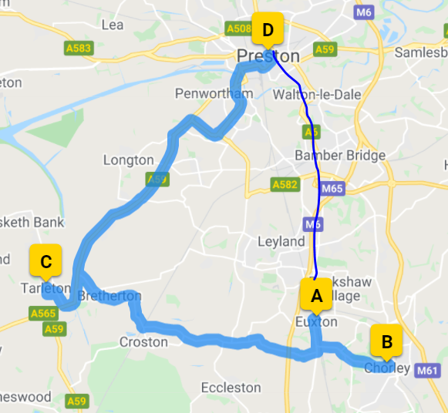

Scenario 2 – L&D Consultant – Visiting a temporary workplace on their way to their permanent workplace
An L&D Consultant who lives in Ormskirk (A) is required to travel to Tarleton (B) to deliver some training for an hour that morning, they then travel onto their permanent workplace at County Hall in Preston (C) to deliver some remote training for the rest of the day before returning home at the end of the day.
As their travel takes them on their usual route to their permanent workplace, this would be considered to be a visit to a temporary workplace on the way to their permanent workplace. They would therefore only be able to claim their actual mileage for the journey, less their normal commuting mileage (if this incurred any additional mileage). If they did not incur any additional cost, they would not have any mileage to claim. Employees are expected to take a sensible approach to travel, taking the most direct route wherever possible.

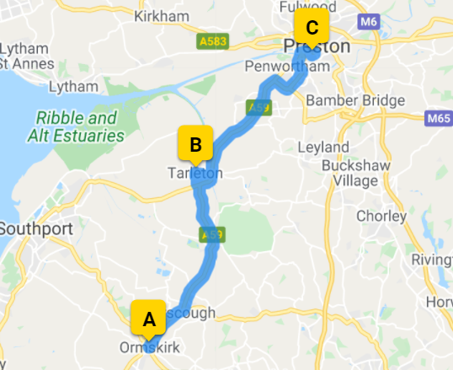

Scenario 3 – Estates Manager – Lives outside of county boundary
An Estates Manager who lives in Southport is required to travel to a meeting in Ormskirk, and then onto Burscough to conduct a building assessment before returning home. Their permanent workplace is County Hall in Preston. As they are required to attend work at these locations for a temporary purpose the travel would be claimable – but only once they reach the county boundary.
- Their travel from their home in Southport (A) to the county boundary on Southport Road (B) would not be claimable as it is outside of the county boundary.
- Their travel from the county boundary (B) to Ormskirk (C), and onto Burscough (D) would be claimable as they are visiting those workplaces for a temporary purpose.
- Their travel from Burscough (D) to the county boundary (B) would be claimable as it is a return journey from a temporary workplace.
- Their travel from the county boundary (B) to Southport (A) would not be claimable as it is outside of the county boundary.

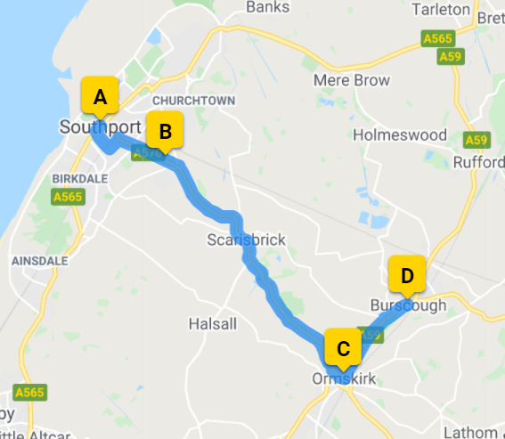

Scenario 4 – Registered Care Manager – Lives outside the county boundary and is required to visit a temporary workplace that is also outside of the county boundary
A Registered Care Manager who lives in Bolton is asked to provide support to a care home in Bury which sits outside of the county boundary.
Whilst the Registered Care Manager lives outside of the county boundary, as their travel takes them to a temporary workplace which also sits outside of the county boundary, they are eligible to claim for the full mileage.
Scenario 5 – HR Business Partner - Deducting normal commuting
A HR Business Partner travels from their home in Bamber Bridge direct to a temporary workplace in Garstang. The journey requires them to travel past and beyond their permanent place of work (County Hall in Preston), coming within a five-mile radius of County Hall. After completing their duties at the temporary workplace, they then return to their permanent workplace. The HR Business Partner claims the distance from home to the temporary workplace whilst deducting their normal commute into their permanent place of work, the travel from Garstang to County Hall in Preston is considered a return journey from a temporary workplace and therefore this travel is claimable.
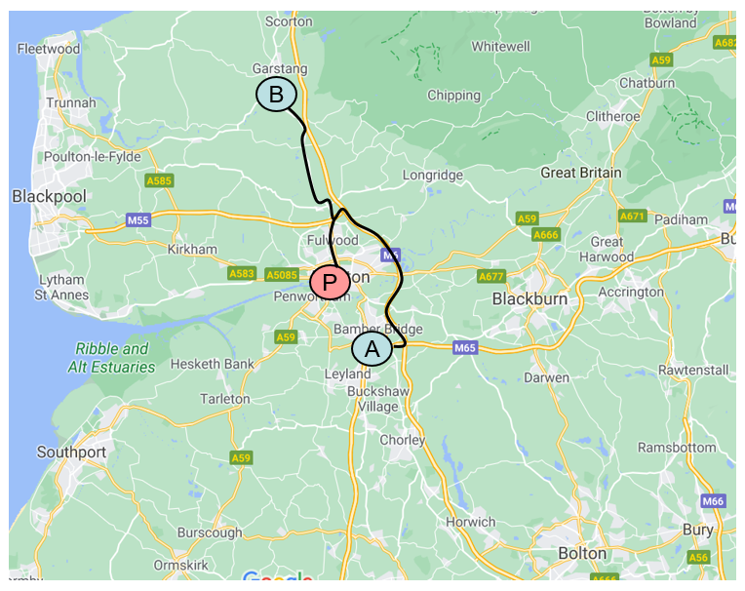
You can calculate if you come within the five-mile radius by looking at roughly the closest point of passing the permanent workplace and calculating the distance via an online platform such as Google Maps where you can measure the distance to the point (see example below):
- Using a route finder, such as AA route planner, identify roughly the closest point where you pass the designated workplace – in the example below this would be on the A59 where the M6 passes the permanent workplace.
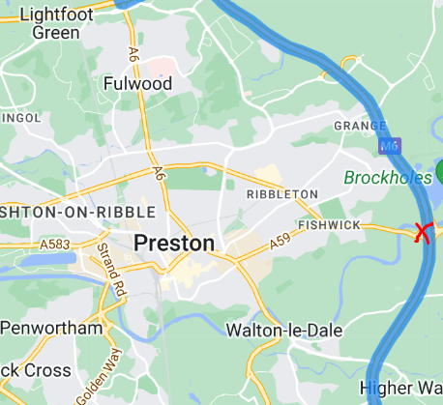
- Go to Google Maps and search for the point where you most closely pass the workplace by right clicking on the point where you will pass the workplace, then select 'measure distance':
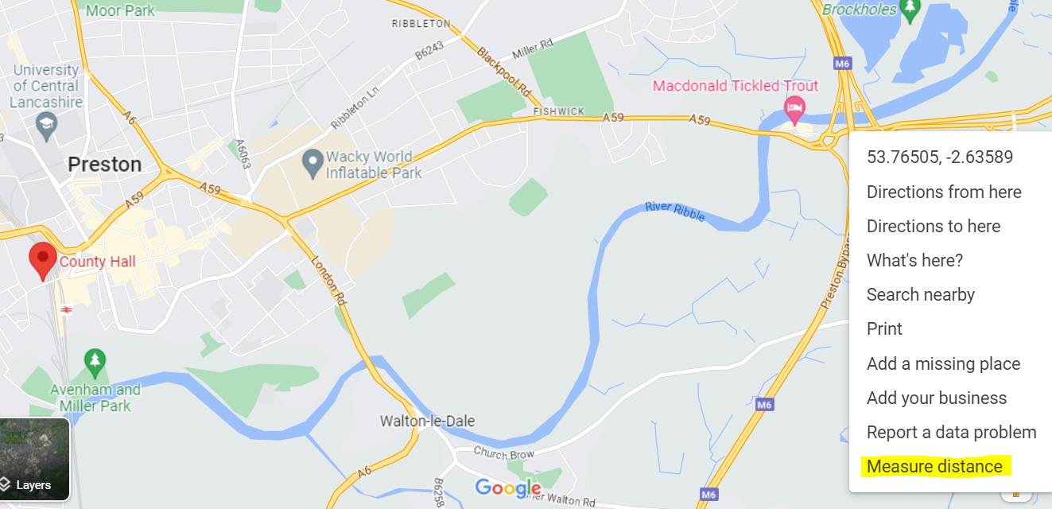
- Then left click on your permanent workplace to calculate the distance. In this case, you can see if shows the total distance as being 2.94 miles, which therefore falls into the five-mile radius, where the usual commute needs to be deducted:
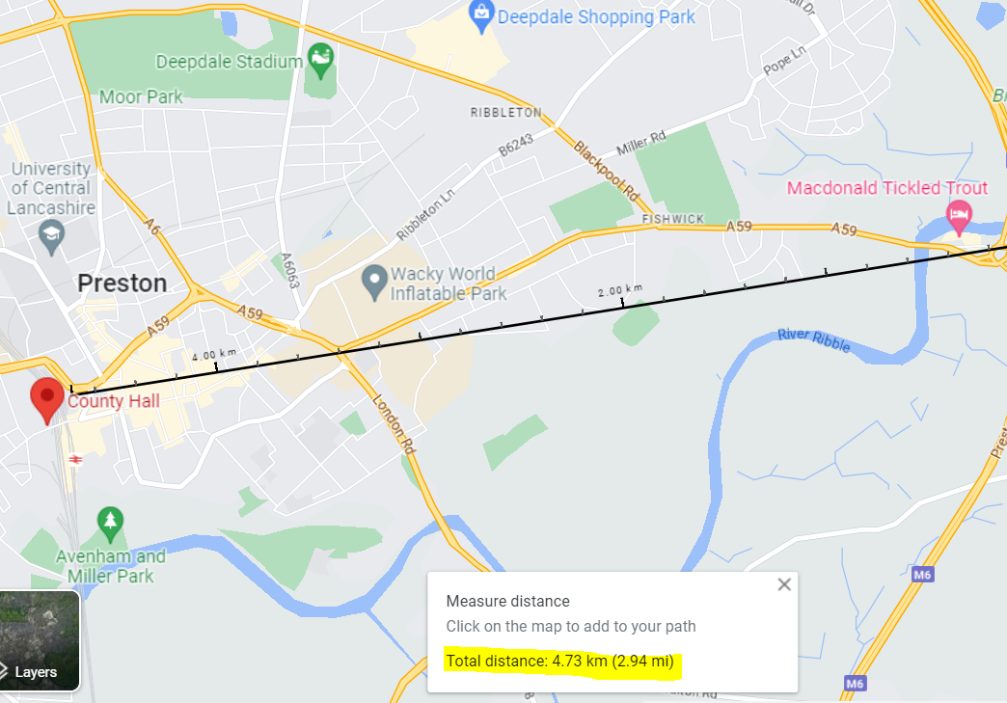
Scenario 6 – Facilities Management Operative - Travel only to temporary workplaces
A Facilities Management operative is required to travel from their home in Bamber Bridge (A), to Chorley (B), to Skelmersdale (C) and finally to Ormskirk (D) before returning home at the end of the day to Bamber Bridge (A). Their permanent workplace is County Hall in Preston. Their visits at all locations listed are for a temporary purpose.
As the operative is travelling to all of the locations for a temporary purpose, and the first temporary workplace does not fall within a five-mile radius, mileage for all of their journeys is therefore claimable.
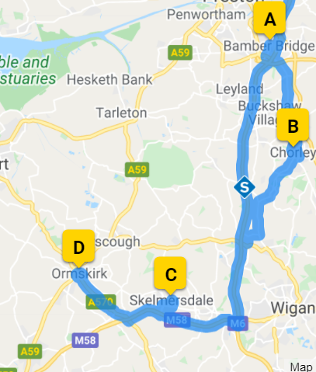

Scenario 7 – Social Worker – Travels within 5-mile radius during visits to temporary workplaces
A social worker's permanent workplace is Mill 14 in Lancaster. They need to travel from their home in Galgate (A) to Bailrigg (B) before going on to Heysham (C) and then returning home (A).
Whilst their first journey from A to B comes within the five-mile radius, as they have not exceeded their usual commute, and as the travel is from home to a temporary workplace, this journey is claimable in full. Their journey from B to C is considered travel from one temporary workplace to another temporary workplace, which again means this travel is claimable in full. The travel from C to A is considered a return journey from a temporary workplace which would again be claimable in full.
The determining factor as to whether to deduct your usual commute is whether that initial journey comes within a five-mile radius and exceeds your usual commute, under which circumstances you would need to deduct your normal commute from the claim.
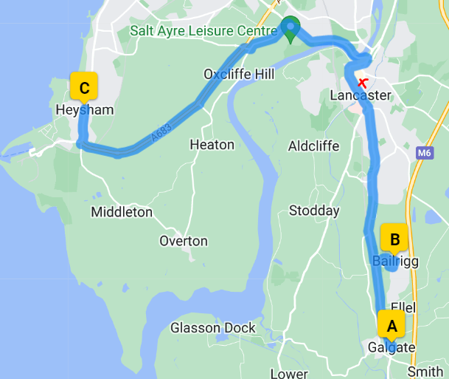
HMRC Examples
Example 1 – Normal commuting
- James works 5 days a week at County Hall which is his permanent workplace. From Monday to Thursday he travels to County Hall in Preston from his home. This journey is ordinary commuting. However, on a Thursday he always goes out for the evening with friends and often stays at a friend’s house overnight from where he travels directly into work in the morning. His journey from his friend’s house to his permanent workplace is also ordinary commuting as it’s travel to a permanent workplace from a place which is not a workplace.

Example 2 – Temporary Workplace
- Fred is a safety officer at County Hall. He visits the Ormskirk depot every week to carry out a particular safety check. His responsibility for that depot has been a duty of his employment for a period already spanning 20 years (so it’s not of limited duration). However, the tasks he performs on each visit are self-contained and the purpose of each visit, considered alone, is temporary. Fred is entitled to claim for the full cost of his travel from home to the Ormskirk depot.

Example 3 – Not a Temporary Workplace

- Guy is an administrator. He has a permanent workplace in Leyland. At certain times of the year he has work to do over the weekend. Generally, he takes it with him to his holiday cottage in the Lake District where he goes with his family most weekends. Working in the Lake District does not make his holiday cottage a temporary workplace. His journey there is private travel and therefore would not be claimable.

Example 4 – Not Travel for Work Purposes

- As part of her duties as a supervisor for a number of social workers at different locations, Hannah has to visit different offices. She gets tax relief for her travel. However, in addition Hannah is usually invited to the Christmas parties held at these offices. She cannot claim for this travel because it’s not for work purposes.

More information on HMRC rules around business mileage can be found here.

